Jobs Management System

User Specifications

Developed for Circle Signs/Rhino Linings Rustenburg

Developed by: A. Prinsloo, F. Prinsloo

# Description

The Jobs Management System (JMS) is used to handle quote creation and distribution and managing of jobs. The system keeps records for these quotes and jobs including job history for job management. It uses intuitive workflows to guide user interaction.

# Scope

The system manages quotes and jobs including job history.

The system allows for creating new quotes or to copy an existing quote. A quote can have more than one line item and includes functionality for sending the quote to the customer via e-mail. Jobs can be created from a quote where one line item on the quote represents one job.

History is recorded for each job to record its progress. A job status is set for each stage in the workflow and includes open, assigned, Pending, In Progress, completed and closed. The system keeps history of every action, with action dates, department, and owner.

For the system to function effectively additional information is required. This includes records for customers, employees, and departments.

Report included is “Open jobs” view indicating customer, job start date, and latest progress history.

# Architecture

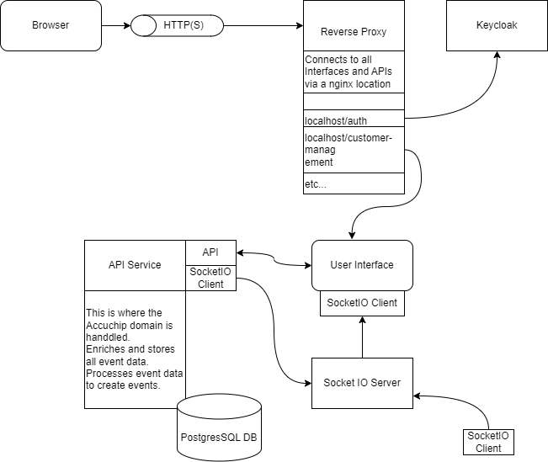

# Data Model

## Data tables

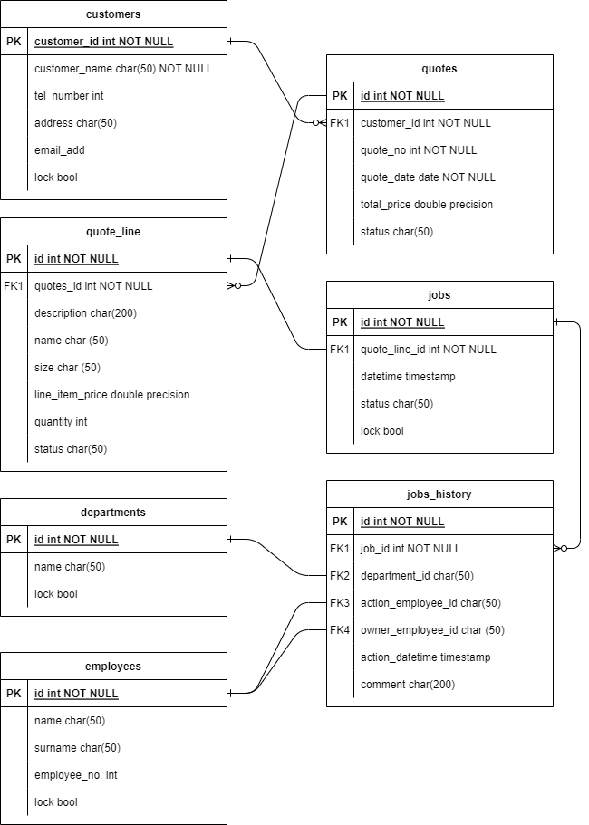

## Statuses

Note : a “closed status” means the records are not available for user manipulation, only for reporting.

Quotes: Open, Sent, Accepted, Rejected (closed status, no jobs created), Cancelled (closed status, jobs created), Closed (closed status)

Jobs: open (status after creation), closed (when last job history is closed), cancelled (with comments, Delete jobs button).

Job history: open, assigned, pending (with comments), in progress, Completed, Closed

# Workflows

## Diagram

## Business rules

### Each line item on the quote represents a job, thus the quote must be constructed to support this.

### Quote date is populated automatically when the “Send” button is pressed.

### Copy function for closed quotes to copy an existing quote with new quote number.

### The system will change the quote status to “closed” when all jobs linked to the quote is in a closed status.

### Pressing “create jobs” is an action that verifies the customer’s acceptance of the quotation. Jobs details cannot be changed after customer acceptance.

### Jobs assigned to employees through push action (allocated status). Jobs accepted by employees through pull action (in progress).

### Jobs can be put on hold by placing it in a “Pending” status. A reason must be captured when setting this status.

### When a job is finished the owner “Complete” the job on the system. When a completed job is inspected/delivered it must be “closed” on the system.

### Jobs can be “Deleted” when a quote was accepted but the customer cancelled to request. This changes the job status to “cancelled”.

## User groups, roles

|  | Function | System admin | Reception | Management | Supervisor | Employee |
| --- | --- | --- | --- | --- | --- | --- |
| Quotes | New Quote | X | X | X |  |  |
| Edit Quote | X | X | X |  |  |
| Copy Quote | X | X | X |  |  |
| Quote | New Quote Line | X |  | X |  |  |
| Send Quote | X |  | X |  |  |
| Create jobs | X | X | X |  |  |
| Save Quote | X | X | X |  |  |
| Jobs | Edit | X | X | X | X | X |
| Job Details | Assign | X | X | X | X |  |
| Accept | X | X | X | X | X |
| Pending | X | X | X | X | X |
| Complete | X | X | X | X | X |
| Close (closed status) | X | X | X | X |  |
| Employees/ Customers/ Departments | New | X | X | X |  |  |
| Delete | X | X | X |  |  |

# Look and Feel

## User Forms

To be included after customer requests implemented…

## Colour scheme

To be discussed with customer…

# Development Process

## Main components

### Reverse proxy

### Role Mapping

### Front end (UI)

### Server setup (socket IO)

### API service

### Database (PostgreSQL)

### Data migration

### After deployment Support (remotely for 6 months)

## Timelines

2 months (End February 2024) depending on final specification

## Terms

50% dep (R6k + R6k)

50% after implementation (R12k)